



Module Code & Module Title
CS6P05NI Project
Proposal

5% Individual Coursework
Submission: Final Submission
AY 2025 2026
Academic Semester: Autumn Semester 2025

Credit: 30 Credit Year Long Module

Student Name: Viom Lal Shrestha
London Met ID: 23048612
College ID: NP01AI4A230041
Assignment Due Date: Wednesday, December 3, 2025
Assignment Submission Date: Tuesday, December 2, 2025
Internal Supervisor: Alish K.C
External Supervisor: Rozeen Nakarmi

I confirm that I understand my coursework needs to be submitted online via MST Classroom under the relevant module page before the deadline for my assignment to be accepted and marked. I am fully aware that late submissions will be treated as non-submission and a mark of zero will be awarded.
Table of Contents
1. Introduction 1
1.1 Problem Scenario 1
1.2 Project as a solution. 2
2. Aims and Objectives 3
3. Expected Outcomes and Deliverables 4
3.1 Software Deliverables 4
3.2 Technical deliverables: 4
3.3 Documentation: 4
4. Project risks, threats and contingency plans 5
5. Methodology 6
5.1 Phases 6
6. Resource Requirement 8
6.1 Hardware Requirements 8
6.2 Software Requirements 8
6.3 Cloud/External Compute Resources 8
6.4 Datasets 8
7. Work Break Down Structure 9
8. Milestones 11
9. Gantt Chart 13
10. Conclusion 14
11. Bibliography 15
12. Appendix 17
12.1 Gantt Chart Task Table 17

Table of Figures
Figure 1: Iterative Incremental Model 6
Figure 2: WBS 9
Figure 3: WBS Part-1 10
Figure 4: WBS Part-2 10
Figure 5: Gantt Chart 13

Table of Tables
Table 1: Project risks/threats and contingency plane 5
Table 2: Milestone Table 11
Table 3: Gantt Chart Task Table 17

1. Introduction
In our chaotic everyday world where life is becoming fast paced, and we as humans are seeking new ways to make our way of life easy and more convenient, one of the most important aspects of our everyday life, being our daily wear is still not up to date to our steady fast lifestyle. We know that clothes make the first impression and are a way to express ourselves, but not everyone of us are born with a sense of style and most of us struggle with making our outfit in a hurry through unorganized closets and hit and trial on matching clothes. Studies suggest that an average person spends about 10-17 minutes per day to choose an outfit, some can decide in seconds while some even take 30 minutes or more (Quora, 2015).
To solve this ‘Closet Buddy’ comes: an AI powered virtual closet assistant, that can help us organize our wardrobe and create daily outfit for us while also keeping track of our outfits and clothes.

1.1 Problem Scenario
As of 2024 people are buying 60% more clothing items than 15 years ago (McKinsey & Company, 2025). Not only this but clothing is only worn 7 to 10 times before being thrown away, a decline of 35% than 15 years ago (uniformmarket, 2025). The fashion sector generates 92 million tonnes of textile waste annually, of which a significant portion ends up in landfills (United Nations Environment Programme (UNEP), 2025).
Many people struggle with their wardrobes and outfit coordination, leading to time inefficiencies while dressing. Research shows that on average only 20% of the clothes owned are worn on a regular basis (The Carbon Literacy Trust, 2025) and a survey revealed that 61% of the respondents forget what they own, which results in unnecessary purchases and low reuse rate (Bang, 2022). A person on average feel like they have nothing to wear at least 36 times a year which is termed as “wardrobe panic”, especially for big dates or event (HERStyle, 2023).
Traditional wardrobe management is completely manual, unstructured and offers no intelligent solutions to visualize their wardrobe, track usage frequency, and receive intelligent outfit recommendations. This lack of a unified digital platform results in wasted time, disorganized storage and under-utilization of owned clothes.

1.2 Project as a solution.
To address both the personal and environmental challenges, the proposed project titled “Closet Buddy” aims to develop an AI-driven virtual wardrobe application that digitalizes a user’s storage spaces and manages the storage units to better help them organize, understand, and reuse their existing wardrobe to facilitate the users. Key features include:
- Clothing image authentication to organize data.
- Automated segmentation and classification of the uploaded clothing item.
- A virtual storage system (Closets/Drawers/Boxes) in which the users can map their real-life storage spaces digitally.
- Users can view all their pieces and filter by type and usage or view items by storage space.
- A recommendation ai suggests coordinated outfits, helping users make better styling choices
- The system tracks usage frequency of the clothes and prioritizes underused garments to encourages sustainable fashion.
- Integrates with weather to give useful suggestions.
- Helps the users to improve their fashion sense by rating the outfits user create.

2. Aims and Objectives
Aim:
To develop an AI-powered virtual storage and wardrobe assistant that authenticates and digitizes clothes into a well-structured storage component, recommends daily outfits based on user requirements, promotes sustainability, and integrates with weather Api to enhance user convenience and reduce fast-fashion-driven waste.
Objectives:
- To provide the users with a user-friendly convenient way to manage and track their real-life storage spaces, specially targeted towards clothing management and keeping record of their outfits.
- To integrate authentication, classification and outfit recommendation features with AI and provide the users with a service to generate outfits according to their requirements.

3. Expected Outcomes and Deliverables
At the end of this project “Closet Buddy” is expected to deliver:
  - Software Deliverables:
- A fully functional AI-powered virtual storage management application with following features:
    - User authentication and profile management.
    - Clothing item authentication after uploading image.
    - Clothing segmentation, and classification of clothing metadata.
    - Virtual storage dashboard with all the user storage spaces.
    - Clothing item to be uploaded on specified storage space, can be edited.
    - Storage spaces can also be used to store non-clothing items.
    - Outfit recommendation hybrid engine (Rule-based + AI) that improves with user rating.
    - Clothes inside the storage spaces that are “put away” will not be used for outfit generation.
    - Users can create their own outfit which can be rated by ai.
    - Providing helpful tips and suggestions based on weather.

3.2 Technical deliverables:
- Authentication model to validate clothing item.
- ML pipelines.
- RESTful API architecture.
- Database schema.
- Responsive frontend interface.

3.3 Documentation:
- Technical documentation with system designs, models, work break down structure.
- Test reports and evaluation of models.
- A Project report.

4. Project risks, threats and contingency plans
Table 1: Project risks/threats and contingency plane
S. No. | Risk/Threat | Effect | Impact | Contingency Plan
1. | Segmentation accuracy issues | Poor cutout quality | Medium | Using stronger models, option to proceed without segmentation, asking the user to provide high quality pictures.
2. | Model misclassification | Incorrect tags | High | Fine-tune models with custom dataset, manual correction option, segment images before processing.
3. | Frontend and backend having integration issue | Data loss, loss of functionality. | High | Ensuring smooth integration between backend and frontend.
4. | Data loss | Loss of workable data. | High | Regular backups, cloud storage.
5. | Time constraints for feature completion | Incomplete project | Medium | Prioritize core features, add buffer time.
6. | Users not uploading appropriate images | AI Model will not work as intended | High | Giving clear guidelines and instruction on what type of image to upload, adding validation.
7. | Clothing image authentication error. | Wrong uploads or correct images being rejected | High | Using a better classification model or architecture.
8. | Weather Api malfunctioning | Suggestions can not be made based on weather | Low | Using good quality Apis.

5. Methodology
The Iterative Incremental Model was deemed suitable for the methodology of this project because this method helps to break down complex projects into smaller parts instead of figuring out everything at the beginning (geeksforgeeks, 2024). It combines structured development with flexibility allowing the developers to focus on making each part working well before adding more, resulting in a better overall system.
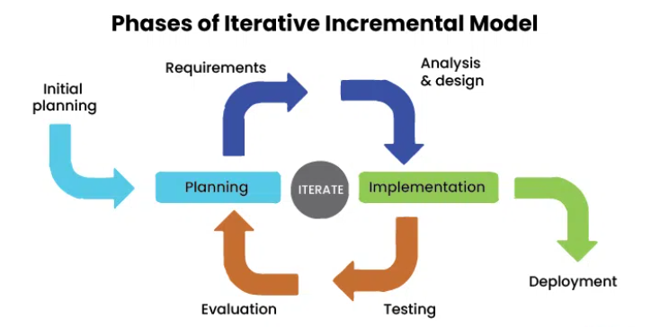
Figure 1: Iterative Incremental Model
The system will be built through small increments, where each increment adds functional components like authentication, segmentation, classification, closet storage, recommendations, etc. Each increment itself goes through iterations of planning, design, implementation, and testing, ensuring continuous refinement and reduced development risk. This model aligns perfectly well with the experimental and modular nature of the project especially in AI-driven components.

5.1 Phases
- Requirement Analysis and Planning
- Collect functional requirements of the project: segmentation, classification, outfit recommendation, storage units.
- Define the non-functional requirements.
- Prepare datasets for classification.
- Identifying external dependencies.
- System and Architecture Design
- Architecture Design: Flutter frontend, Django Backend, AI Layer, PostgreSQL database.
- Design Dataflow.
- Design recommendation pipeline.
- Incremental Development Cycles
The development will be carried out in different incremental development cycles to complete feature on time and for review.
- Increment 1: Authentication module
- Increment 2: Segmentation module
- Increment 3: Classification module
- Increment 4: Storage system development
- Increment 5: Recommendation AI with weather feature integration
- Increment 6: Final system development and integration
- Testing and Evaluation
- Unit tests for each feature.
- UI testing of Flutter.
- Integration testing for backend and frontend
- Model performance testing.
- Performance testing
- Final system testing
- Deployment (Not within the project Scope)
- Deploy backend to cloud (AWS)
- Connect Flutter app to deployed API
- Maintenance and Iteration
- Fixing bugs and refining UI
- Perform optimization based on feedback
- Finalize report and documentation

6. Resource Requirement

6.1 Hardware Requirements
- Good quality laptop with the following specifications:
    - 32 GB RAM
    - Multi-core processor (Intel i9 or equivalent)
    - SSD storage (512GB or higher)
    - GPU (NVIDIA RTX 4050 or equivalent)
- A standard mobile phone

6.2 Software Requirements
- IDE and Testing: Visual Studio Code, Postman, Google Colab/ Jupyter Notebook
- Frontend: Flutter/React Native
- Backend:
    - Python
    - Django
    - TensorFlow/PyTorch/Scikit-learn
    - Hugging face models
- Cloud Storage: AWS
- GitHub for version control
- Database: PostgreSQL

6.3 Cloud/External Compute Resources
If local hardware is insufficient for heavy AI workload:
- Colab T4 GPU/ v5e-1 TPU

6.4 Datasets
- https://github.com/rainalexotl/deepfashion-image-classification

7. Work Break Down Structure
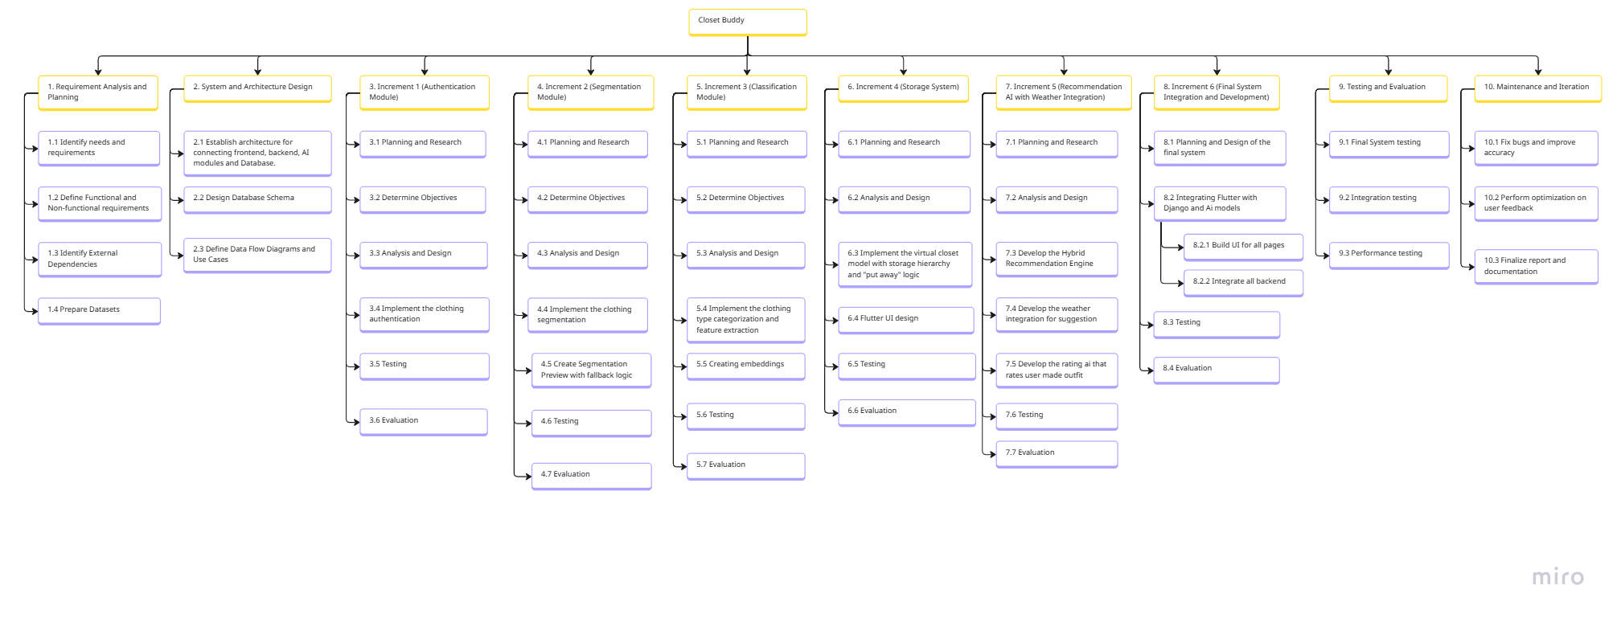
Figure 2: WBS

Partitioning the figure for clarity, WBS Part-1:

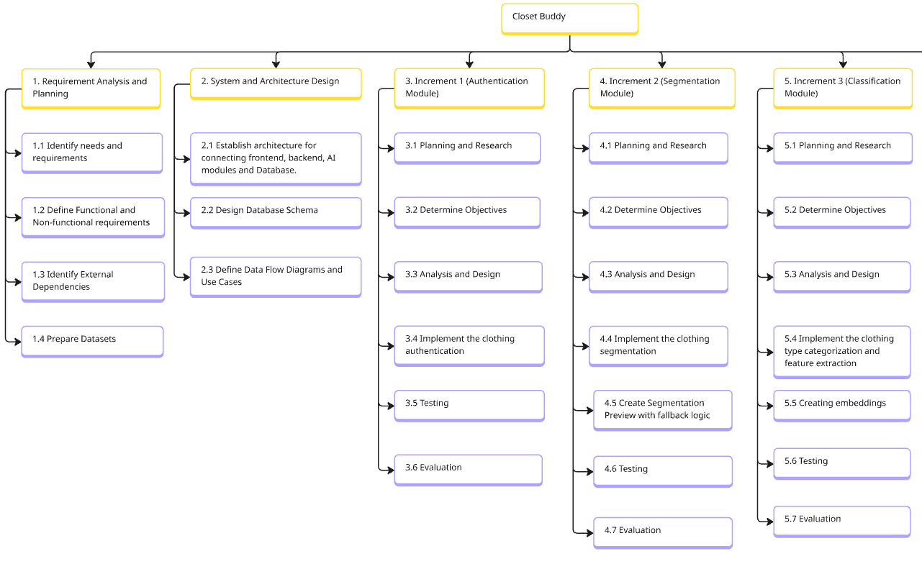
Figure 3: WBS Part-1
WBS Part-2:
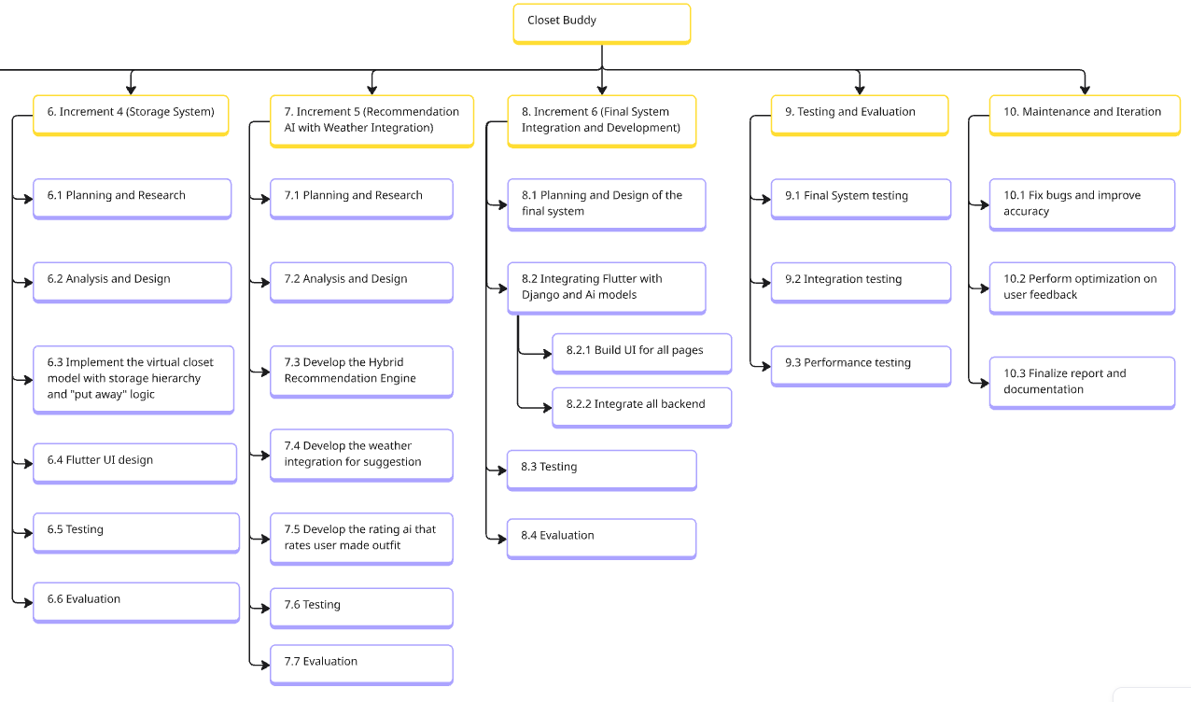
Figure 4: WBS Part-2

8. Milestones
Table 2: Milestone Table
S. No. | Milestone | Target Date | Description
1. | Topic Finalization | November 3, 2025 | “Closet Buddy” was accepted as the FYP topic.
2. | Proposal Submission | December 3, 2025 | A detailed project proposal was submitted.
3. | Authentication and Segmentation functional | December 21, 2025 | The uploaded image is successfully authenticated and segmented
4. | Classification and meta data extraction successful | December 31, 2025 | Successfully extracted clothing meta data like type, category, colour, and made embeddings.
5. | Completed the storage interface | January 10, 2025 | Clothing items are stored in database with metadata and storage units front end completed. Items are displayed in frontend.
6. | Recommendation engine functional | January 18, 2025 | Recommendation engine works and generates outfit.
7. | Weather Integration and AI rating complete. | January 25, 2025 | Gives suggestion based on weather and users can get the outfit they created rated by AI.
8. | Backend Frontend Integration Completed | February 15, 2025 | Full backend complete & stable, flutter UI integrated with backend.
9. | Testing Phase Done | March 25, 2025 | Testing Completed
10. | Final Report Submission | April, 2025 | Final report submitted.

9. Gantt Chart
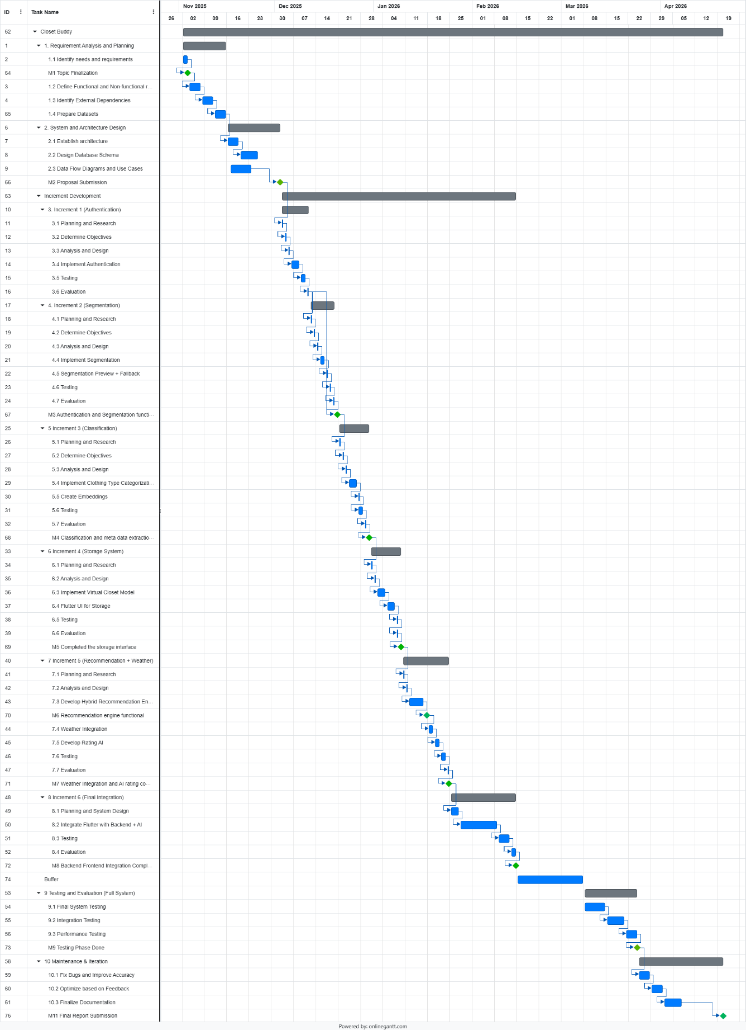
Figure 5: Gantt Chart
Click here to see the task list and its details

10. Conclusion
The project involves the design and development of Closet Buddy, and AI-powered wardrobe and storage management application with outfit recommendation system that will fulfil user needs involving the digital organization of one's closet and styling of their outfits. The platform integrates clothing authentication, segmentation, metadata extraction, a virtual grid-based closet, hybrid outfit generation, and weather-aware suggestions into a single powerful application. Designed for ease and convenience, the system emphasizes accessibility, usability, and adaptability across a wide range of users.

Care was taken in the planning, iterative design, and systematic testing to realize reliable performance and accurate AI-driven recommendations. The main focus is the hybrid outfit generation engine that combines both rule based and AI implementation methods for better performance along with a flexible virtual storage model and integration of interactive features that allow for efficient utilization of the wardrobe.

The end result of this project is a user friendly and easy to use centralized application for storage management and digitalization, that not only helps for generating outfit ideas and therefore encouraging the users to actively engage with their already owned clothing collection in a more fun and creative manner while also helping to reduce textile waste and being a personal assistant for the closet. As a bonus it also helps keep our storage spaces organized, mapped, and easy to keep record of.

11. Bibliography
Bang, H. &. S. J., 2022. Who Uses Virtual Wardrobes? Investigating the Role of Consumer Traits in the Intention to Adopt Virtual Wardrobes. January, p. 16.
geeksforgeeks, 2024. Iterative Incremental Model in Designing System. [Online]
Available at: https://www.geeksforgeeks.org/system-design/iterative-incremental-model-in-designing-system/
[Accessed 29 November 2025].
HERStyle, 2023. The REAL Reason You Have a Closet Full of Clothes and Nothing to Wear. [Online]
Available at: https://herstylellc.com/2023/01/17/the-real-reason-you-have-a-closet-full-of-clothes-and-nothing-to-wear/
[Accessed November 2025].
McKinsey & Company, 2025. mckinsey. [Online]
Available at: https://www.mckinsey.com/featured-insights/mckinsey-explainers/what-is-fast-fashion
[Accessed 22 November 2025].
Quora, 2015. How long does it normally take to choose the outfit in the morning? Is dressing up nicely important?. [Online]
Available at: https://www.quora.com/How-long-does-it-normally-take-to-choose-the-outfit-in-the-morning-Is-dressing-up-nicely-important#:~:text=Some%20people%20spend%205%E2%80%9310%20minutes%20deciding%20what,sitting%20down%20for%20most%20of%20the%20day?
[Accessed 25 November 2025].
The Carbon Literacy Trust, 2025. carbonliteracy. [Online]
Available at: https://carbonliteracy.com/fast-fashions-carbon-footprint/
[Accessed 22 Nov 2025].
uniformmarket, 2025. uniformmarket. [Online]
Available at: https://www.uniformmarket.com/statistics/fast-fashion-statistics
[Accessed 22 Novemner 2025].
United Nations Environment Programme (UNEP), 2025. unep. [Online]
Available at: https://www.unep.org/technical-highlight/sustainable-fashion-take-centre-stage-zero-waste-day
[Accessed 22 Nov 2025].

12. Appendix

12.1 Gantt Chart Task Table
Table 3: Gantt Chart Task Table
Task Name | Start | Finish | Duration
1. Requirement Analysis and Planning | 11/2/2025 | 11/15/2025 | 14 day
1.1 Identify needs and requirements | 11/2/2025 | 11/3/2025 | 2 day
M1 Topic Finalization | 11/3/2025 | 11/3/2025 | Milestone
1.2 Define Functional and Non-functional requirements | 11/4/2025 | 11/7/2025 | 4 day
1.3 Identify External Dependencies | 11/8/2025 | 11/11/2025 | 4 day
1.4 Prepare Datasets | 11/12/2025 | 11/15/2025 | 4 day
2. System and Architecture Design | 11/16/2025 | 12/2/2025 | 17 day
2.1 Establish architecture | 11/16/2025 | 11/19/2025 | 4 day
2.2 Design Database Schema | 11/20/2025 | 11/25/2025 | 6 day
2.3 Data Flow Diagrams and Use Cases | 11/17/2025 | 11/23/2025 | 7 day
M2 Proposal Submission | 12/2/2025 | 12/2/2025 | Milestone
Increment Development | 12/3/2025 | 2/14/2026 | 74 day
3. Increment 1 (Authentication) | 12/3/2025 | 12/11/2025 | 9 day
3.1 Planning and Research | 12/3/2025 | 12/3/2025 | 1 day
3.2 Determine Objectives | 12/4/2025 | 12/4/2025 | 1 day
3.3 Analysis and Design | 12/5/2025 | 12/5/2025 | 1 day
3.4 Implement Authentication | 12/6/2025 | 12/8/2025 | 3 day
3.5 Testing | 12/9/2025 | 12/10/2025 | 2 day
3.6 Evaluation | 12/11/2025 | 12/11/2025 | 1 day
4. Increment 2 (Segmentation) | 12/12/2025 | 12/19/2025 | 8 day
4.1 Planning and Research | 12/12/2025 | 12/12/2025 | 1 day
4.2 Determine Objectives | 12/13/2025 | 12/13/2025 | 1 day
4.3 Analysis and Design | 12/14/2025 | 12/14/2025 | 1 day
4.4 Implement Segmentation | 12/15/2025 | 12/16/2025 | 2 day
4.5 Segmentation Preview + Fallback | 12/17/2025 | 12/17/2025 | 1 day
4.6 Testing | 12/18/2025 | 12/18/2025 | 1 day
4.7 Evaluation | 12/19/2025 | 12/19/2025 | 1 day
M3 Authentication and Segmentation functional | 12/20/2025 | 12/20/2025 | Milestone
5. Increment 3 (Classification) | 12/21/2025 | 12/30/2025 | 10 day
5.1 Planning and Research | 12/21/2025 | 12/21/2025 | 1 day
5.2 Determine Objectives | 12/22/2025 | 12/22/2025 | 1 day
5.3 Analysis and Design | 12/23/2025 | 12/23/2025 | 1 day
5.4 Implement Clothing Type Categorization | 12/24/2025 | 12/26/2025 | 3 day
5.5 Create Embeddings | 12/27/2025 | 12/27/2025 | 1 day
5.6 Testing | 12/27/2025 | 12/28/2025 | 2 day
5.7 Evaluation | 12/29/2025 | 12/29/2025 | 1 day
M4 Classification and meta data extraction successful | 12/30/2025 | 12/30/2025 | Milestone
6. Increment 4 (Storage System) | 12/31/2025 | 1/9/2026 | 10 day
6.1 Planning and Research | 12/31/2025 | 12/31/2025 | 1 day
6.2 Analysis and Design | 1/1/2026 | 1/1/2026 | 1 day
6.3 Implement Virtual Closet Model | 1/2/2026 | 1/4/2026 | 3 day
6.4 Flutter UI for Storage | 1/5/2026 | 1/7/2026 | 3 day
6.5 Testing | 1/8/2026 | 1/8/2026 | 1 day
6.6 Evaluation | 1/8/2026 | 1/8/2026 | 1 day
M5 Completed the storage interface | 1/9/2026 | 1/9/2026 | Milestone
7. Increment 5 (Recommendation + Weather) | 1/10/2026 | 1/24/2026 | 15 day
7.1 Planning and Research | 1/10/2026 | 1/10/2026 | 1 day
7.2 Analysis and Design | 1/11/2026 | 1/11/2026 | 1 day
7.3 Develop Hybrid Recommendation Engine | 1/12/2026 | 1/16/2026 | 5 day
M6 Recommendation engine functional | 1/17/2026 | 1/17/2026 | Milestone
7.4 Weather Integration | 1/18/2026 | 1/19/2026 | 2 day
7.5 Develop Rating AI | 1/20/2026 | 1/21/2026 | 2 day
7.6 Testing | 1/22/2026 | 1/23/2026 | 2 day
7.7 Evaluation | 1/24/2026 | 1/24/2026 | 1 day
M7 Weather Integration and AI rating completed | 1/24/2026 | 1/24/2026 | Milestone
8. Increment 6 (Final Integration) | 1/25/2026 | 2/14/2026 | 21 day
8.1 Planning and System Design | 1/25/2026 | 1/27/2026 | 3 day
8.2 Integrate Flutter with Backend + AI | 1/28/2026 | 2/8/2026 | 12 day
8.3 Testing | 2/9/2026 | 2/12/2026 | 4 day
8.4 Evaluation | 2/13/2026 | 2/14/2026 | 2 day
M8 Backend Frontend Integration Completed | 2/14/2026 | 2/14/2026 | Milestone
Buffer | 2/15/2026 | 3/7/2026 | 21 day
9. Testing and Evaluation (Full System) | 3/8/2026 | 3/31/2026 | 24 day
9.1 Final System Testing | 3/8/2026 | 3/14/2026 | 4 day
9.2 Integration Testing | 3/15/2026 | 3/20/2026 | 4 day
9.3 Performance Testing | 3/21/2026 | 3/24/2026 | 4 day
M9 Testing Phase Done | 3/25/2026 | 3/25/2026 | Milestone
10. Maintenance & Iteration | 3/25/2026 | 4/21/2026 | 21 day
10.1 Fix Bugs and Improve Accuracy | 3/25/2026 | 3/28/2026 | 4 day
10.2 Optimize based on Feedback | 3/29/2026 | 4/1/2026 | 4 day
10.3 Finalize Documentation | 4/2/2026 | 4/07/2026 | 6 day
M10 Final Report Submission | 4/21/2026 | 4/21/2026 | Milestone

Click here to go back to Gantt Chart

